Guthrie Township

Hubbard County Minnesota

2024 Annual Meeting Minutes March 12th 2024

-----------------------------------------------------------------------------------

The Township of Guthrie, Hubbard County Minnesota held its annual meeting on March 12th 2024.

At 7:00 P.M. the Clerk Amanda Fallgren called the meeting to order with the pledge. The sign in roster indicated that twenty-three people attended the meeting.

The Clerk introduced the Board and instructed the people to elect a moderator who was to conduct the remainder of the meeting. Roger Corson nominated Russ Nickerson and David Johnson seconded the motion. No other motions for the moderator were made, Russ Nickerson accepted the nomination.

Rebecca Theis read the treasurers report and detailed the data that was approved at the Board of Audit meeting. There were multiple copies of the 2023 financial report made available to the public. Ryan Johnson motioned to accept and Candy Barthel seconded the motion. The report was approved as read.

The Clerk then read the minutes of the last year’s (2023) Annual Meeting Minutes. Ryan Johnson motioned to accept and Candy Barthel seconded the motion and approved as read with one amendment made to include the word “not” in the statement, “the state **not** having the funding to resolve the steep incline of 440th”.

Mr. Schmidt (Board Supervisor) provided a road report which included the following:

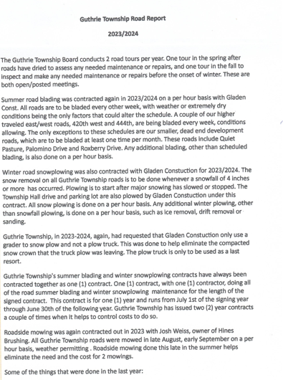

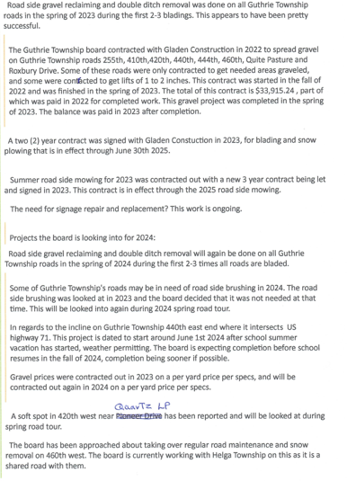

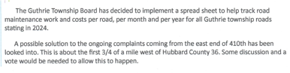

**The floor was open for general discussion:**

Russ Nickerson expressed concerns with waiting until the beginning of August to start/complete roadside mowing. Russ suggests that the board look into seeing if roadside mowing can be started in mid-July. Mike Schmidt will look into this. David Johnson also asked why roadside mowing didn’t get completed until September, when it was indicated that work was to begin mid-August 2023. Mike Schmidt replied, that Josh Weiss had some set-backs with equipment.

David Johnson also asked about the work with the steep incline correction on 440th and travel for people coming and going on that road. Mike Schmidt and Les and Riley from Gladen’s will be looking into alternate route options for the people living on 440th, as well as temporary mailboxes. Work is ideally to start in June after school is out and be completed before school resumes in the fall.

Shannon Nelson with Lakeport Emergency Medical Responders was in attendance and presented statistics for 2023:

In 2023, the Lakeport Area Emergency Medical Responders were called to 390

medical/emergency calls within the 236 square miles of our coverage area as well as outlying

mutual aid areas. We currently have 21 volunteer members who respond to these emergencies

24 hours a day – 7 days a week. Of those 21 volunteers, 6 are Emergency Medical Technicians

(EMTs), 7 are Emergency Medical Responders (EMRs) and 8 are EMR apprentices.

In late 2023 we started an EMR class that trained one new EMR and our 8 EMR

apprentices. They finished their classes and got certified last month. We are excited to have

them joining us and look forward to mentoring the next generation of EMR apprentices. EMR

apprentices are fully trained and certified EMRs that are aged 16 and 17 years old. They

respond to emergencies alongside our other EMTs and EMRs in order to be ready to respond on

their own once they turn 18. We hope that your continued support will help us to equip all these

new responders with the proper equipment they need.

In 2023 we began carrying additional medications to increase the pre-ambulance and

pre-hospital care we can provide patients. These new medications are Benadryl for allergic

reactions and Albuterol for asthma attacks. These medications, as well as the equipment needed

to administer them have been an added expense to our annual budget.

We are proud to be one of the only groups in the area that has equipped every responder

with an AED. That is largely due to your support and grant funding. These AEDs have saved

lives in our community! We thank you for being a part of that! Your financial support will help

us with ongoing training, equipment, supplies, and medications needed to keep our organization

running. Your generous donations help us to be there when you need us most.

Ivy Knoshaug presented the Ye’ Ol School Grounds Annual Report. There was a total of 20 renters with 13 of those being from Guthrie Township handouts were also provided outlying the details of the Income and Expenses for 2023. Total Income $7,763.59 and Total Expenses $3,935.95

In 2023 the Ye’ Ol School Grounds was able to get a new Playground set, with $15,341 received in donations. There will be a plaque placed at school grounds listing the donors for the playground set.

Donation requests received were reviewed.

Candy Barthel made a motion to cap this year’s donations to $2,000. Ivy Knoshaug seconded the motion. Motion carried

Steve Rogers motioned 2023 donation to Lakeport Medical Responders for $2,000 and David Johnson seconded the motion. Motion carried.

TOWNSHIP LEVIES

David Johnson made a motion to levy $36,000 to the General Fund and Steve Rogers seconded the motion. Motion carried.

Ryan Johnson made a motion to levy $70,000 to The Road and Bridge Fund and Steve Rogers seconded the motion. Motion carried.

Mike Schmidt made a motion to levy $2,000 to the Cemetery Fund and Steve Rogers seconded the motion. Motion carried.

Roger Corson made a motion to levy $7,800 to the Fire Fund and Mike Schmidt seconded the motion. Motion carried

Russ Nickerson made a motion to levy $3,000 to the Building Fund and Ivy Knoshaug seconded the motion. Motion carried.

No further discussions and Candy Barthel made a motion to have next year’s meeting at 7:00 PM on the second Tuesday in March and to have the Bemidji Pioneer as the official newspaper. Mike Schmidt seconded the motion. Motion carried.

Mike Schmidt made a motion to adjourn the meeting. Roger Corson seconded the motion. Meeting Adjourned.

Submitted by: Amanda Fallgren – Clerk

3//2024